ESP32 C++ Autopilot Build (for wheel or tiller) – 2023

Item | Cost | Link
Arduino ESP32 devkit | $9 | https://www.ebay.com/itm/284415393405
12v to 5v buck converter chip | $1 | https://www.ebay.com/itm/201986611110 or similar
9-axis IMU compass (LSM303) | $15 | https://www.ebay.com/itm/202091223251
IR Remote & Receiver (optional) | $5 | https://www.ebay.com/itm/224263591887
Push button (optional) | $.50 | Local shop
BTS7960 (IBT-2) Motor Controller | $13 | https://www.ebay.com/itm/112571698699
Thermal pad for controller (optional) | $3 | https://www.ebay.com/itm/313578863749
Motorbike belt drive kit with belt and 2 gears (1:4 ratio) (for wheel) | $45 | https://www.ebay.com/itm/174775590807
Windshield wiper motor  (wheel pilot) | $35 | https://www.ebay.com/itm/163899761480
Wiper motor box w/ clutch | ? | Motor is secured inside a wood box using hose clamps. This box sits on top of a wood base that is secured to the steering pedestal with large hose clamps. The base and box are connected with a hinge and a homemade bolt latch. The hinge allows good belt tension underway plus ability to disengage motor linkage quickly.
Linear Actuator (alternative to wiper motor for tiller pilot) | $86 | https://www.ebay.com/itm/304592763080?var=603617299724  (300mm stroke, 300Newton, 45 mm/s)
Dupont cable jumper wires assortment | $6 | https://www.ebay.com/itm/324089639653
Tiller linkage for actuator | ? | Tiller bracket made from strip of 1.5” aluminum, 1/4” bolt, and two U-brackets. Cockpit seat socket made from 1/4” bolt with rubber bushing for top, and a 2” wood block glued under the cockpit locker hatch, with a 3/8” hole drilled and filled with epoxy and an embedded nut (stand a greased bolt up threaded through the nut while the epoxy is curing).
LCD (2-row) w/ I2C module (optional) | $7 | https://www.ebay.com/itm/234062594780
Hose clamps | $6 | For mounting motor on steering pedestal
Rudder position indicator (optional but useful for end-of-travel sensing) | $18 | https://www.ebay.com/itm/164145915227  Note: it needs a 1k resistor on a third wire to make work. See diagram.
Wire | -- | (USB cables for IMU & motor controller; 14/16 AWG for install)
Total (all options for wheel) | $164 | Excludes cost of scrap wood for box, various hardware (bolts, screws, U-brackets, hose clamps), enclosure (be creative!), and cables.
Total (barebones with just ESP32, IBT-2, and IMU, no drive motor, rudder sensor, or linkage) | $37 | Assumes you have your own motor and steering linkage. All control is via onboard wifi HTML interface.

Note: total cost could be cheaper if you are patient for parts to arrive from overseas.

To build:

Motor Linkage (for wheel):
- Attach small gear from belt drive kit to the windshield wiper motor. I did this by using red threadlocker to fix a nut onto the bolt on the end of the motor output, then fitting the gear snugly around the nut. Fill the center gap with JB Weld and hold level while it cures. Drill a small hole through the gear and bolt shaft and tap in a small piece of steel wire as a set pin.
- Connect the incoming 12v power from the controller, + to green and – to the loose wire. On my motor, fast speed was green and slow speed was yellow. Note: I used a 2-wire trailer connection from an auto parts store as a waterproof plug.
- Affix large gear from belt drive kit to the backside of your steering wheel using U-brackets.

LSM303 IMU (compass):
- Option 1: Remote stashable compass:
  - Cut both ends off of a USB cable no longer than 2m. Solder the wires from one end to VIN, GND, SDA, and SCL.
  - On the other end of the USB cable, attach female header pins for connecting to the ESP32. The lazy route is to clip, splice, and heat shrink Dupont wires onto the USB wire ends.
  - Glue the IMU to something you can firmly stick somewhere in the centerline area of the boat away from ferrous metals or electric fields. I used a tic-tac box.
- Option 2: direct attachment to ESP32
  - Don’t use a USB cable at all. Solder dupont wires to the IMU, glue the IMU to a plastic strip glued to the underside of the ESP, and plug in the IMU to the ESP. This whole arrangement fits inside a small prescription bottle.

IBT-2 motor controller:
- Decide where you want the controller relative to the motor/actuator and the ESP32 unit. The IBT-2 should not be right next to the compass or the electrical fields will interfere.
- Find a USB cable of appropriate length and cut off the heads. Expose the 4 wires on either end.
- Splice three female Dupont cables to the red wire in the USB cable. Splice one female Dupont wire to each of the other 3 USB cable wires.
- Connect the three red wires to VIN, L-EN, and R-EN. Connect black wire to GND and other two wires to LPWM and RPWM.
- Connect incoming 12V wire of at least 14AWG to the BATT +/- inputs
- Connect Motor +/- to motor or linear actuator. Polarity is reversible and doesn’t really matter.

ESP32 and components
- Run a 12v line from your boat breaker panel to the 12v>5v buck converter chip. Solder the +/- input to the input side of the buck converter. Cut the large head off a microUSB cable and expose the 4 wires inside. Connect the red and black wires to the +/- of the output pins on the buck converter. To waterproof this, I put a small piece of water hose over the connection and filled it with silicone. The microUSB male plugs into the ESP32.
- Cut a small rectangle out of a hobby breadboard and glue it to the underside of the ESP. This will be your power bus. Connect the VIN and GND pins to the +/- sides of the bus using Dupont wires. This will supply 5v to all components. You could also use the 3.3V pin on the ESP32 if your specific components need the lower voltage.
- Connect your components to the ESP board as follows:
  - MPU9255 compass
    - VIN = + bus
    - GND = - bus
    - SDA = pin 21
    - SCL = pin 22
  - IBT-2 motor controller
    - VIN = + bus
    - GND = -bus
    - L-EN = + bus (splice with VIN)
    - R-EN = + bus (splice with VIN)
    - LPWM = 32
    - RPWM = 33
    - Connect incoming 12V +/- and outgoing motor +/- where indicated
  - Rudder sensor (optional but recommended if you use a wiper motor or an actuator without end of travel stop switches. The actuator linked above has EoT switches.)
    - VIN = + bus
    - GND = - bus
    - SENS = pin 34
  - LCD screen (optional)
    - VIN = + bus
    - GND = - bus
    - SDA = pin 21 (splice with compass IMU or designate additional SDA/SCL pins in code)
    - SCL = pin 22 (splice with compass IMU or designate additional SDA/SCL pins in code)
  - On/Off button (optional)
    - + = pin 5
    - - = - bus
  - IR receiver (optional)
    - VIN = + bus
    - GND = - bus
    - SENS (center) = pin 27

Uploading the code to the ESP32
- Download and install the Arduino IDE software on your computer.
- Install the ESP32 boards and libraries into the Arduino IDE. Here is a good tutorial: https://randomnerdtutorials.com/installing-the-esp32-board-in-arduino-ide-windows-instructions/
- Make sure the following libraries are installed in your Arduino folder. Some can be added from within the IDE, while others have to be searched on the web and downloaded for manual installation through the Sketch>Include Library>from .zip menu option.
  - <LiquidCrystal.h>
  - <LiquidCrystal_I2C.h>
  - <Wire.h>
  - <Bounce2.h> // use for red button toggle pilot on/off
  - <L3G.h> // IMU compass
  - <BTS7960.h> // IBT-2 motor controller library
  - <IRremote.h> // infrared remote control
  - <LSM303.h> // IMU compass
  - <WiFi.h>
  - <AsyncTCP.h>
  - <ESPAsyncWebServer.h>
  - <AsyncElegantOTA.h>
- Connect the ESP32 to your computer using the USB cable and select the board ESP32 devkit v1.
- Upload the autopilot sketch and hold the “Boot” pin on the ESP32 until it’s done. It will take a few minutes.
- After the first time uploading, any future changes you make to the code may be loaded via the wifi connection by exporting a binary and going to 192.168.4.1/update.

Operation:

- Turn on power to the ESP32 and after a moment, connect to the SSID of the autopilot (current password is “thereyouare”). Direct your browser to 192.168.4.1 to reach the pilot interface. Feel free to rename the SSID and password, located near the top of the main .ino file.

- It’s an autopilot! Turn it on and tell it to go somewhere.

- The PID variables are tunable from within the HTML interface, but they reset every time you turn it on. To permanently change the default PID settings, rudder deadband, or magnetic variation offset, you need to change them in the main .ino file and reupload the arduino sketch to the ESP32.

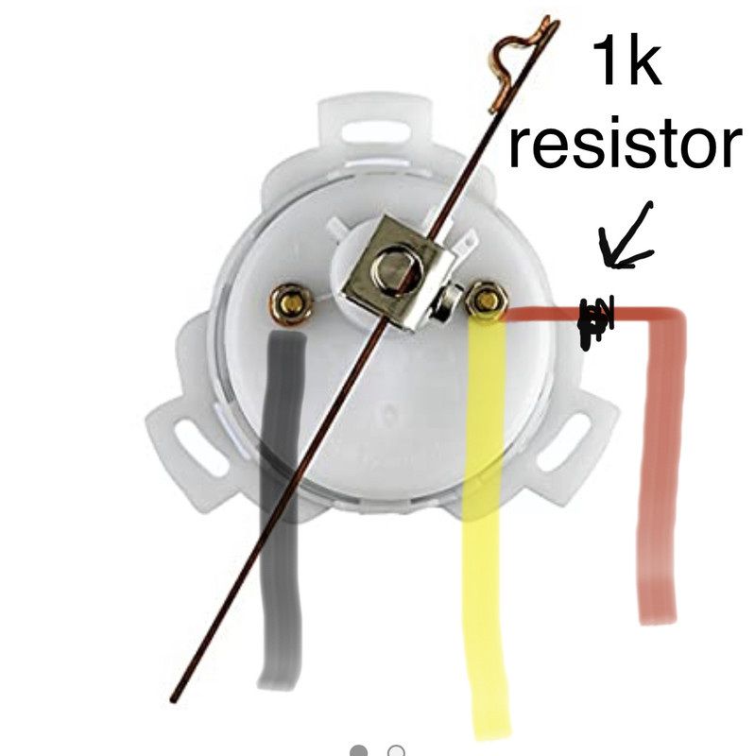
Rudder Position Sensor wiring:
If you get the el cheapo rudder position indicator linked in the parts list, you will need to wire it like so:

Photos of my hardware install for wheel and tiller:



